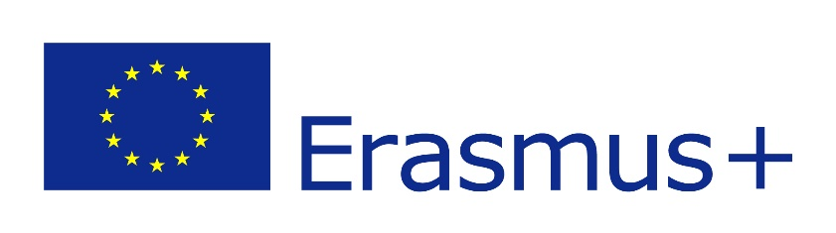

D3.4c | Recommendations based on behavioural analysis
2020-1-CY01-KA226-VET-082750
Remote Class System

Authors | SVR, AUTh, GEO and VS
Abstract | The current deliverable presents the key recommendations based on the behavioural analysis conducted during the 2nd prototype field test. This analysis enables us to understand the factors that influence the decision-making process of teachers/professors and students, and how different experiences affect the acceptance of technology in educational settings. This deliverable aims to assist end-user organizations in conducting consistent testing of the real prototype and provides guidance for the technical partners in the development of the CLASSY platform.

The consortium
No. | Partner Name |  | Logo
1 | GeoImaging | Geoimaging ltd
2 | AUTH | Aristotle University of Thessaloniki
3 | VS | Virtual Solutions
4 | SVR | SchooVR | 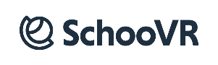

Disclaimer
The information in this document is subject to change without notice. Company or product names mentioned in this document may be trademarks or registered trademarks of their respective companies.
All rights reserved
The document is proprietary of the Classy consortium members. No copying, distributing, in any form or by any means, is allowed without the prior written agreement of the owner of the property rights.
This document reflects only the authors’ view. The European Community is not liable for any use that may be made of the information contained herein.

Contents
The consortium 2
Disclaimer 2
Contents 3
1. Introduction 4
2. Previous work 5
3. Behavioural analysis methodology 7
4. Recommendations based on behavioural analysis 7
Conclusions 10
References 11
Annexes 11

- Introduction
CLASSY project’s main objective is to bring immersive 3D guided lessons into education using an accessible browser agnostic approach. The CLASSY project has received funding from the EU’s Erasmus+ Call 2020 Round 1 KA2 – Cooperation for innovation and the exchange of good practices (Grant Agreement: 2020-1-CY01-KA226-VET-082750). More specifically, CLASSY project aims to offer the following services in a user-friendly environment for teachers, students, and education professionals:
- Development of a platform that offers a novel, technically advanced and appealing e-learning method that is accessible to students and teachers both remotely and in class.
- Immersive educational experiences by interacting with a variety of virtual reality (VR) learning resources.
- A system that allows teachers and students to create and launch unique learning resources in a convenient way.
The present deliverable includes the main conclusions and considerations deriving from the results of the 2nd prototype field test in Ireland and Greece. The present deliverable includes the main recommendations based on the behavioural analysis conducted during the 2nd prototype field test. These insights allow us to understand the factors that influence the decision-making process of teachers/professors and students, and how different experiences affect the acceptance of technology in educational settings. This deliverable will support end-user organizations in conducting consistent testing of the real prototype and provide guidance for the technical partners in the ongoing development of the CLASSY platform.

- Previous work
During the user requirement phase, which can be found in detail in D1.2 ‘Scenarios and User Requirements’, work was carried out under a report aimed at defining the projects target groups, scenarios, and personas.
Several potential user scenarios were created for the CLASSY platform. These included:
- A high school teacher
- A high school student
- A university professor
- A scenario with a user from the outside of education institutes
- A lifelong learner
- A user with a disability
- A VET (Vocational, Educational and Training) trainer
A questionnaire survey method was selected to reach out to CLASSY targeted stakeholders to map their needs and preferences. The main objective of the survey was to identify and explore the obvious and/or hidden user needs and increase the chances of CLASSY being effectively adopted in practice as well as providing users with an accessible VR education platform.
An overview of the survey results suggested the following:
- The potential users of CLASSY cover different user categories with different characteristics.
- Most of the target groups were familiar with remote education.
- A large proportion of users did not own virtual reality equipment.

Mock-up Field Tests
The current study employed a combination of a questionnaire survey and cognitive walkthrough to gather feedback from the targeted users of the CLASSY platform, including teachers/trainers and students/trainees. The primary objectives of the study were to identify both obvious and hidden user needs, in order to develop more customized services with increased chances of being adopted by teachers and students in real-world environments. To achieve this, several scenarios were created using a mock-up and a questionnaire survey, which were used to gather information from the participants. This method allowed us to gain a deeper understanding of how the platform is being used and the areas where improvements can be made to enhance the overall user experience. The results of the study will be used to inform and improve the design of the platform for the final deployment, ensuring that it meets the needs and expectations of its targeted users.

1st Prototype Field Tests
The primary goal of the 1st prototype field tests was to evaluate the quality of the prototype by obtaining feedback from real users. These tests were designed to identify both obvious and hidden user needs. A series of scenarios, along with corresponding actions, were completed during the field tests. Facilitators meticulously documented any comments, issues, or problems encountered, as well as any discrepancies or difficulties experienced by students, teachers, and educational professionals. Both students and teachers/lecturers/professors participated in the field tests, providing feedback through a combination of scenarios and surveys/questionnaires. The data gathered from the 1st prototype field test was utilized to enhance the usability and effectiveness of the CLASSY platform. The feedback and suggestions provided by the teachers and students were instrumental in addressing issues and addressing the needs of the target users, thus facilitating a more seamless and user-friendly experience.
The first prototype can be accessed here: https://app.classy-project.eu/

- Behavioural analysis methodology

Behavioural analysis is a method of understanding and modifying behaviour by examining the relationship between behaviour and its consequences. It has both theoretical and practical applications and is commonly used to teach individuals more effective ways of behaving and learning new skills. During the CLASSY field tests, the behaviour technique of prompting was used to support participants. Prompting involves providing a cue, either verbal or visual, to elicit a desired response. During the mock-up and field tests, participants were guided through the testing process by professionals from SVR and AUTh who collected responses from a questionnaire survey and also observed and recorded information about the participants' behaviour as they navigated through different scenarios and features of the platform. Verbal feedback and notes were also collected to assist end-user organizations in conducting consistent testing of the real prototype and to provide guidance for the technical partners in the development of the CLASSY platform.

- Recommendations based on behavioural analysis
During 2nd prototype field testing phase, a combination of methods such as cognitive walkthrough, questionnaire survey, and corresponding listed actions were used to gather valuable insights from users about their behaviour and actions while using the CLASSY platform. This provided the SVR and AUTh teams with a comprehensive understanding of how users interact with the platform and any areas that may need improvement. This information will be used to make necessary adjustments to the prototype and ensure that the final product meets the needs of users.

Teachers
A group of teachers and lecturers (50) participated in the testing of the first prototype, evaluating its functionality and usability through a series of carefully designed scenarios. Led by facilitators from both SVR and AUTh, the participants navigated the platform, providing feedback and insights through a survey upon completion. The testing phase focused on three key features of the platform, examining their functionality, ease of use, and overall user experience. The results of these tests will be used to inform further development and improvements to the platform, ensuring that it meets the needs and expectations of its intended users.
A detailed analysis of teacher responses can be found in D3.3c ‘Deployment of pilots in a real environment’.

Students
A group of students (50) participated in the evaluation of the 2nd prototype of the CLASSY platform, guided through a set of pre-determined scenarios by facilitators from SVR and AUTh. After completing each scenario, the students were asked to provide feedback through a survey, allowing for a detailed examination of two key features of the platform. The results of this evaluation will be used to inform further development and improve the user experience for future users of the CLASSY platform.
These key features included:
- Joining the Colosseum environment
- Interacting with 3D content
A detailed analysis of student responses can be found in ‘D3.3c Deployment of pilots in a real environment’.

4.1 Recommendations: 2nd Prototype field test
During the 2nd prototype field testing phase, a combination of methods such as real prototype scenarios and a questionnaire survey were used to gather valuable insights from users about their behaviour and actions while using the CLASSY platform. To gather a comprehensive understanding of the platform's usability, two distinct groups of users were asked to complete separate questionnaires and corresponding listed actions. This provided a more detailed understanding of the user experience and helped identify specific areas of improvement. The information collected during these field tests, including observations on the behaviour of the users, was carefully analysed by the teams from AUTh and SVR to inform further development of the platform.
Recommendations
General Suggestions
A number of general suggestions were made during the 2nd prototype field test. Many users wanted to see more content including a 3D live environment, its integration will be the next step of the final development. Additionally, users suggested the inclusion of more interactive teaching and learning activities, such as polls, quizzes, questions, and audio. This would enhance the educational experience and make it more engaging for students. Furthermore, many users highlighted the need for clearer signposting and tutorials to aid in the navigation and use of the platform.

Interactive activities
During the 2nd prototype field test, many users expressed a desire for more functionality within the CLASSY platform. Specifically, students suggested the ability to use different types of emoji to communicate with the teacher and other students in the experience, in order to enhance the interactive and engaging nature of the learning experience. Teachers also expressed a desire for additional features, such as a whiteboard tool or interactive assessments like quizzes or polls, to better facilitate their ability to engage with students and evaluate their understanding of the material. These suggestions highlight the importance of continued development and improvement of the CLASSY platform to better meet the needs and preferences of both students and teachers.
The process of selecting and customizing avatars proved to be a popular feature among the students who participated in the field tests of the CLASSY platform's 2nd prototype. Students were able to successfully add a username and select a colour for their avatars, and many praised the smooth transition into the 3D environment upon starting the experience.

Sketchfab API
During the 1st and 2nd pilot tests, many users successfully created interactive, immersive experiences using the CLASSY content creation tools. However, some users encountered difficulty when importing 3D models from Sketchfab, a platform that provides access to millions of 3D assets for subjects such as science, social studies, and architecture. The authentication and login process for Sketchfab was identified as a source of confusion for some users. To address this issue, clear signposting to help users understand its functionality are needed. Additionally, it was recommended that more ready-made models be made available without the need for logging in to Sketchfab, in order to streamline the content creation process.

Platform tutorials and signposting
The users who participated in the field tests of the CLASSY platform's 2nd prototype expressed a desire for more clear signposting and tutorials to assist in learning how to use the platform. Some teachers found the navigation slightly confusing and suggested that clearer steps for joining a lesson would be beneficial. Additionally, some teachers had difficulty using the Sketchfab integration, specifically with adding assets to each scene. They requested more documentation and guidance in order to make the process more user-friendly.
In conclusion, for the deployment of the final product, the following improvements are deemed necessary for trainers, educators, and students to be able to complete the testing:
- More interactive activities
- Improved Sketchfab integration
- Platform tutorials and signposting

Conclusions
Overall, the 2nd prototype field test provided valuable insights into the potential of the CLASSY platform to enhance teaching and learning experiences. However, the results also highlighted a number of areas that require further development to ensure that the platform is user-friendly and meets the needs of educators and students. These include improving navigation, integrating more interactive content and activities, and addressing issues with the Sketchfab integration. The feedback and suggestions provided by the users will be integral in guiding the technical partners as they work to address these issues and enhance the final product.

References
[1] Behaviour Analysis in Psychology, Kendra Cherry. Available at: https://www.verywellmind.com/what-is-behavior-analysis-2794865 (Accessed: 11/08/2022)

Annexes
ANNEX II:
CLASSY MOCK-UP FIELD TEST QUESTIONAIRE
English Form of Classy – Remote Class System Questionnaire Dear participant, welcome to our survey! Classy is an EU Erasmus+ (GA No 2020-1-CY01-KA226-VET-082750) project which aims at promoting remote education using a 3D simulation of a classroom.
Classy endeavours to develop a remote education platform that will address the needs both of the teachers/trainers and the students. Thus, we need your help to design a virtual classroom that will meet your requirements! We invite you to participate in the following survey and provide us with feedback about your current experience with virtual reality applications and what do you expect from a virtual reality education software!
The survey lasts about 10 minutes. There are no right or wrong answers, this is only about your personal views. All data are anonymized, and your privacy is guaranteed. Before participating in the survey please read carefully the information sheet that is available here: Information Sheet Thank you for helping us gather relevant information! There are 18 questions in this survey.
I declare that I have read all the information, I know the objectives of this survey and I agree to participate. By participating in this survey I authorize the use of the data collected for the purposes of the research as described in the terms set out in the information sheet (You can find it here).

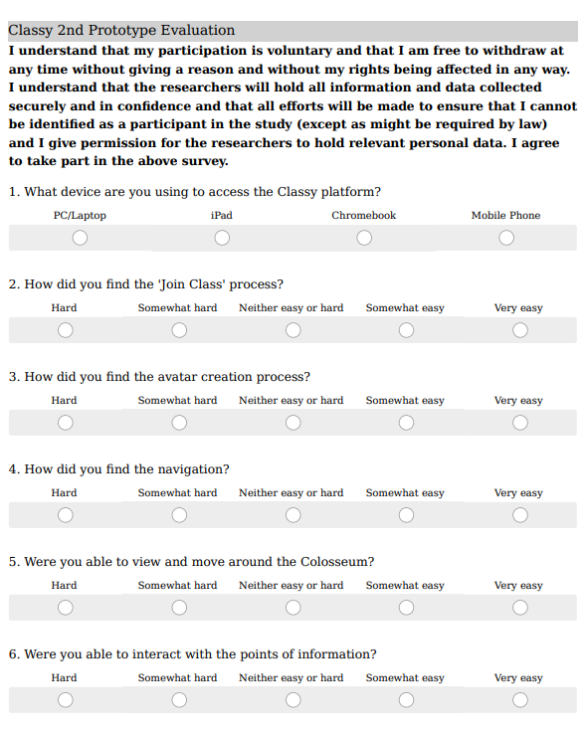
2nd Prototype evaluation – Student Survey

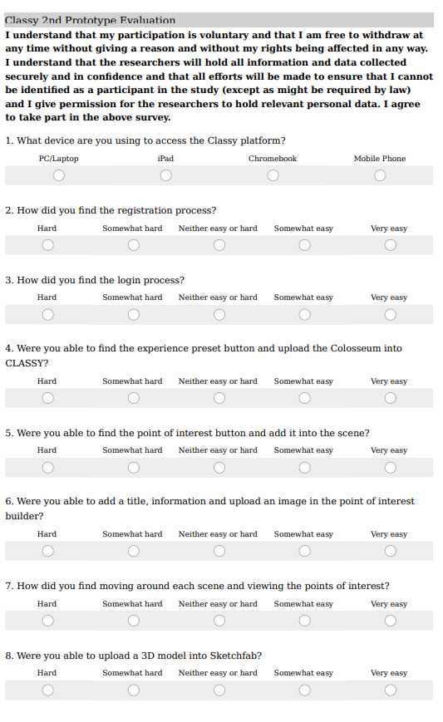
2nd prototype evaluation - Teacher Survey
