D3.4b | Recommendations based on behavioural analysis
2020-1-CY01-KA226-VET-082750
Remote Class System

Authors | SVR, AUTh, GEO and VS
Abstract | The current deliverable presents the key recommendations based on the behavioural analysis conducted during the 1st prototype field test. This analysis enables us to understand the factors that influence the decision-making process of teachers/professors and students, and how different experiences affect the acceptance of technology in educational settings. This deliverable aims to assist end-user organizations in conducting consistent testing of the real prototype and provides guidance for the technical partners in the development of the CLASSY platform.

The consortium
No. | Partner Name |  | Logo
1 | GeoImaging | Geoimaging ltd
2 | AUTH | Aristotle University of Thessaloniki
3 | VS | Virtual Solutions
4 | SVR | SchooVR

Disclaimer
The information in this document is subject to change without notice. Company or product names mentioned in this document may be trademarks or registered trademarks of their respective companies.
All rights reserved
The document is proprietary of the Classy consortium members. No copying, distributing, in any form or by any means, is allowed without the prior written agreement of the owner of the property rights.
This document reflects only the authors’ view. The European Community is not liable for any use that may be made of the information contained herein.

Contents
The consortium 2
Disclaimer 2
Contents 3
1. Introduction 4
2. Previous work 5
3. Behavioural analysis methodology 7
4. Recommendations based on behavioural analysis 7
Conclusions 10
References 11
Annexes 11

- Introduction
CLASSY project’s main objective is to bring immersive 3D guided lessons into education using an accessible browser agnostic approach. The CLASSY project has received funding from the EU’s Erasmus+ Call 2020 Round 1 KA2 – Cooperation for innovation and the exchange of good practices (Grant Agreement: 2020-1-CY01-KA226-VET-082750). More specifically, CLASSY project aims to offer the following services in a user-friendly environment for teachers, students, and education professionals:
- Development of a platform that offers a novel, technically advanced and appealing e-learning method that is accessible to students and teachers both remotely and in class.
- mmersive educational experiences by interacting with a variety of virtual reality (VR) learning resources.
- A system that allows teachers and students to create and launch unique learning resources in a convenient way.
The present deliverable includes the main conclusions and considerations deriving from the results of the 1st prototype field test in Ireland and Greece. The behaviour analysis permits us to understand the factors influencing the behaviour of teachers/professors and students in the decision-making process, and how experiential factors influence the acceptance of technologies in educational institutions. This deliverable will provide direction to the efforts of the technical partners for the development of the CLASSY platform.

- Previous work
During the user requirement phase, which can be found in detail in D1.2 ‘Scenarios and User Requirements’, work was carried out under a report aimed at defining the projects target groups, scenarios, and personas.
Several potential user scenarios were created for the CLASSY platform. These included:
- A high school teacher
- A high school student
- A university professor
- A scenario with a user from the outside of education institutes
- A lifelong learner
- A user with a disability
- A VET (Vocational, Educational and Training) trainer
A questionnaire survey method was selected to reach out to CLASSY targeted stakeholders to map their needs and preferences. The main objective of the survey was to identify and explore the obvious and/or hidden user needs and increase the chances of CLASSY being effectively adopted in practice as well as providing users with an accessible VR education platform.
An overview of the survey results suggested the following:
- The potential users of CLASSY cover different user categories with different characteristics.
- Most of the target groups were familiar with remote education.
- A large proportion of users did not own virtual reality equipment.

Mock-up Field Tests
The current study employed a combination of a questionnaire survey and cognitive walkthrough to gather feedback from the targeted users of the CLASSY platform, including teachers/trainers and students/trainees. The primary objectives of the study were to identify both obvious and hidden user needs, in order to develop more customized services with increased chances of being adopted by teachers and students in real-world environments. To achieve this, several scenarios were created using a mock-up and a questionnaire survey, which were used to gather information from the participants. This method allowed us to gain a deeper understanding of how the platform is being used and the areas where improvements can be made to enhance the overall user experience. The results of the study will be used to inform and improve the design of the platform for the final deployment, ensuring that it meets the needs and expectations of its targeted users.
- Behavioural analysis methodology

Behavioural analysis is a method of understanding and modifying behaviour by examining the relationship between behaviour and its consequences. It has both theoretical and practical applications and is commonly used to teach individuals more effective ways of behaving and learning new skills. During the CLASSY field tests, the behaviour technique of prompting was used to support participants. Prompting involves providing a cue, either verbal or visual, to elicit a desired response. During the mock-up and field tests, participants were guided through the testing process by professionals from SVR and AUTh who collected responses from a questionnaire survey and also observed and recorded information about the participants' behaviour as they navigated through different scenarios and features of the platform. Verbal feedback and notes were also collected to assist end-user organizations in conducting consistent testing of the real prototype and to provide guidance for the technical partners in the development of the CLASSY platform.
- Recommendations based on behavioural analysis
During the first prototype field testing phase, a combination of methods such as cognitive walkthrough, questionnaire survey, and corresponding listed actions were used to gather valuable insights from users about their behaviour and actions while using the CLASSY platform. This provided the SVR and AUTh teams with a comprehensive understanding of how users interact with the platform and any areas that may need improvement. This information will be used to make necessary adjustments to the prototype and ensure that the final product meets the needs of users.

Teachers
A group of teachers and lecturers (50) participated in the testing of the 1st prototype, evaluating its functionality and usability through a series of carefully designed scenarios. Led by facilitators from both SVR and AUTh, the participants navigated the platform, providing feedback and insights through a survey upon completion. The testing phase focused on three key features of the platform, examining their functionality, ease of use, and overall user experience. The results of these tests will be used to inform further development and improvements to the platform, ensuring that it meets the needs and expectations of its intended users.
A detailed analysis of teacher and student responses can be found in D3.3b ‘Deployment of pilots in a real environment’.
Students
A group of students (50) participated in the evaluation of the 1st prototype of the CLASSY platform, guided through a set of pre-determined scenarios by facilitators from SVR and AUTh. After completing each scenario, the students were asked to provide feedback through a survey, allowing for a detailed examination of two key features of the platform. The results of this evaluation will be used to inform further development and improve the user experience for future users of the CLASSY platform.
These included:
• Joining a created session
• Interacting with other users and objects in the 3D environment
A detailed analysis of teacher and student responses can be found in D3.3b ‘Deployment of pilots in a real environment’.

4.1 Recommendations: 1st Prototype field test
During the first prototype field testing phase, a combination of methods such as real prototype scenarios and a questionnaire survey were used to gather valuable insights from users about their behaviour and actions while using the CLASSY platform. To gather a comprehensive understanding of the platform's usability, two distinct groups of users were asked to complete separate questionnaires and corresponding listed actions. This provided a more detailed understanding of the user experience and helped identify specific areas of improvement. The information collected during these field tests, including observations on the behaviour of the users, was carefully analysed by the teams from AUTh and SVR to inform further development of the platform.
The first prototype can be accessed here: https://app.classy-project.eu/

Recommendations
General Suggestions
A number of general suggestions were made during the 1st prototype field test. By integrating fewer steps and signposting key features after the registration process we need to make to it easy for users to access the main features. Many users wanted to see more content including a 3D live environment, its integration will be the next step of the 2nd prototype development. Some users also wanted to see more teaching and learning activities including polls, quizzes, questions or even audio.

Content creation
During the 1st pilot tests, many users successfully created interactive, immersive experiences using the CLASSY content creation tools. However, some users encountered difficulty when importing 3D models from Sketchfab, a platform that provides access to millions of 3D assets for subjects such as science, social studies, and architecture. The authentication and login process for Sketchfab was identified as a source of confusion for some users. To address this issue, it was suggested that a larger Sketchfab button be included in future prototypes, along with clear signposting to help users understand its functionality. Additionally, it was recommended that more ready-made models be made available without the need for logging in to Sketchfab, in order to streamline the content creation process.

Avatars
The process of selecting and customizing avatars proved to be a popular feature among the students who participated in the field tests of the CLASSY platform's 1st prototype. The majority of students were able to successfully add a username and select a colour for their avatars, and many praised the smooth transition into the 3D environment upon starting the experience. Overall, Irish users reported finding navigation of the platform to be relatively easy, with a majority indicating it was either "somewhat easy" or "easy". However, some users expressed a desire for more creative options when it came to customizing their avatars. In response to this feedback, the next prototype will include additional avatar features and ways for avatars to communicate with one another.

Engine physics
Many students from Ireland and Greece were able to successfully navigate around the virtual scene using their keyboard during the experience. However, some participants reported challenges with climbing models and moving through the environments, indicating a need for improvement in the platform's physics features. Additionally, after their initial interaction, many users expressed a desire for more virtual models and interactive elements within the experience, suggesting a desire for more engaging and immersive content.
In conclusion, for the deployment of the 2nd prototype, the following improvements are deemed necessary for trainers, educators, and students to be able to complete the testing:
- Improved content creation features
- Avatars creation
- Improved engine physics
- Accessible 3D content that users can explore

Conclusions
Overall, the results from the 1st prototype field test indicate a strong potential for the CLASSY platform to improve teaching and learning experiences. However, certain areas such as navigation, content integration, and interactivity need to be further developed for the platform to be fully embraced by educators and students. The feedback and suggestions provided by the users will be crucial in guiding the technical partners in addressing these issues for the 2nd prototype and ultimately, the final product.

References
[1 Behaviour Analysis in Psychology, Kendra Cherry. Available at: https://www.verywellmind.com/what-is-behavior-analysis-2794865 (06/07/21)

Annexes
CLASSY MOCK-UP FIELD TEST QUESTIONAIRE
English Form of Classy – Remote Class System Questionnaire Dear participant, welcome to our survey! Classy is an EU Erasmus+ (GA No 2020-1-CY01-KA226-VET-082750) project which aims at promoting remote education using a 3D simulation of a classroom.
Classy endeavors to develop a remote education platform that will address the needs both of the teachers/trainers and the students. Thus, we need your help to design a virtual classroom that will meet your requirements! We invite you to participate in the following survey and provide us with feedback about your current experience with virtual reality applications and what do you expect from a virtual reality education software!
The survey lasts about 10 minutes. There are no right or wrong answers, this is only about your personal views. All data are anonymized, and your privacy is guaranteed. Before participating in the survey please read carefully the information sheet that is available here: Information Sheet Thank you for helping us gather relevant information! There are 18 questions in this survey.
I declare that I have read all the information, I know the objectives of this survey and I agree to participate. By participating in this survey I authorize the use of the data collected for the purposes of the research as described in the terms set out in the information sheet (You can find it here).

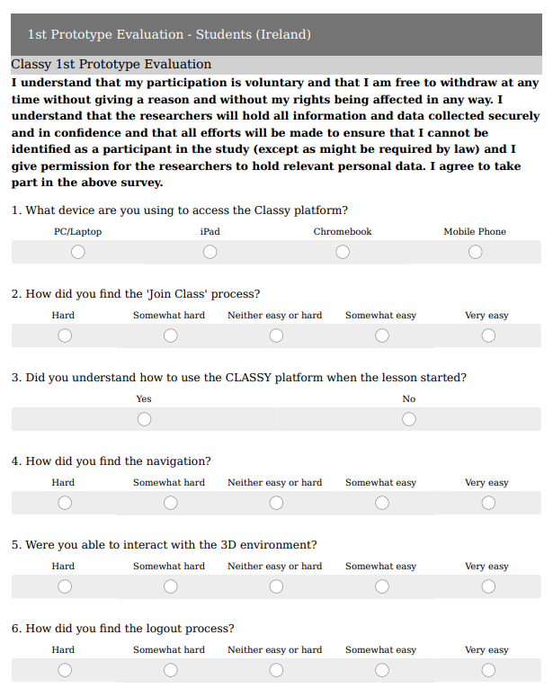
1st Prototype evaluation – Student Survey

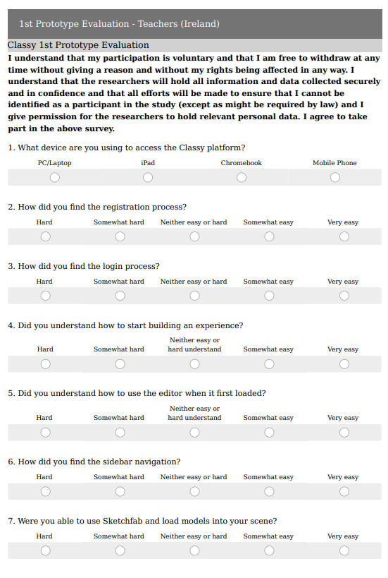
1st prototype evaluation - Teacher Survey

